**Introduction to Machine Learning for Beginners**

We have seen Machine Learning as a buzzword for the past few years, the reason for this might be the high amount of data production by applications, the increase of computation power in the past few years and the development of better algorithms.

Machine Learning is used anywhere from automating mundane tasks to offering intelligent insights, industries in every sector try to benefit from it. You may already be using a device that utilizes it. For example, a wearable fitness tracker like Fitbit, or an intelligent home assistant like Google Home. But there are much more examples of ML in use.

* Prediction — Machine learning can also be used in the prediction systems. Considering the loan example, to compute the probability of a fault, the system will need to classify the available data in groups.
* Image recognition — Machine learning can be used for face detection in an image as well. There is a separate category for each person in a database of several people.
* Speech Recognition — It is the translation of spoken words into the text. It is used in voice searches and more. Voice user interfaces include voice dialing, call routing, and appliance control. It can also be used a simple data entry and the preparation of structured documents.
* Medical diagnoses — ML is trained to recognize cancerous tissues.
* Financial industry and trading — companies use ML in fraud investigations and credit checks.

# What is Machine Learning?

According to Arthur Samuel, Machine Learning algorithms enable the computers to learn from data, and even improve themselves, without being explicitly programmed.

Machine learning (ML) is a category of an algorithm that allows software applications to become more accurate in predicting outcomes without being explicitly programmed. The basic premise of machine learning is to build algorithms that can receive input data and use statistical analysis to predict an output while updating outputs as new data becomes available.

# Types of Machine Learning?

Machine learning can be classified into 3 types of algorithms.

1. Supervised Learning
2. Unsupervised Learning
3. Reinforcement Learning

# Overview of Supervised Learning Algorithm

In Supervised learning, an AI system is presented with data which is labeled, which means that each data tagged with the correct label.

The goal is to approximate the mapping function so well that when you have new input data (x) that you can predict the output variables (Y) for that data.

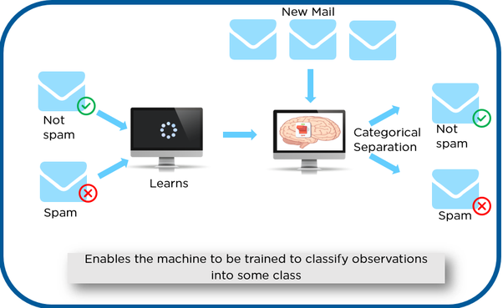

As shown in the above example, we have initially taken some data and marked them as ‘Spam’ or ‘Not Spam’. This labeled data is used by the training supervised model, this data is used to train the model.

Once it is trained we can test our model by testing it with some test new mails and checking of the model is able to predict the right output.

## Types of Supervised learning

* **Classification**: A classification problem is when the output variable is a category, such as “red” or “blue” or “disease” and “no disease”.
* **Regression**: A regression problem is when the output variable is a real value, such as “dollars” or “weight”.

# Overview of Unsupervised Learning Algorithm

In unsupervised learning, an AI system is presented with unlabeled, uncategorized data and the system’s algorithms act on the data without prior training. The output is dependent upon the coded algorithms. Subjecting a system to unsupervised learning is one way of testing AI.

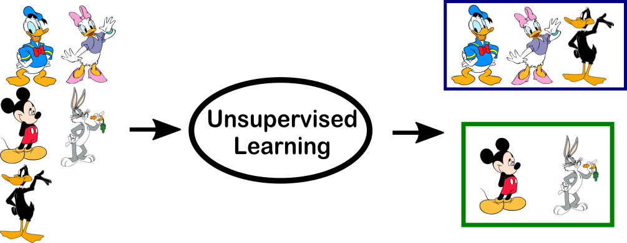

In the above example, we have given some characters to our model which are ‘Ducks’ and ‘Not Ducks’. In our training data, we don’t provide any label to the corresponding data. The unsupervised model is able to separate both the characters by looking at the type of data and models the underlying structure or distribution in the data in order to learn more about it.

## Types of Unsupervised learning

* **Clustering**: A clustering problem is where you want to discover the inherent groupings in the data, such as grouping customers by purchasing behavior.
* **Association**: An association rule learning problem is where you want to discover rules that describe large portions of your data, such as people that buy X also tend to buy Y.

# Overview of Reinforcement Learning

A reinforcement learning algorithm, or agent, learns by interacting with its **environment**. The **agent** receives rewards by performing correctly and penalties for performing incorrectly. The agent learns without intervention from a human by maximizing **its reward and minimizing its penalty**. It is a type of dynamic programming that trains algorithms using a system of reward and punishment.

**There is a critic :** Who will observer the agent form outside & give him indication whether the agent is doing wright or wrong.

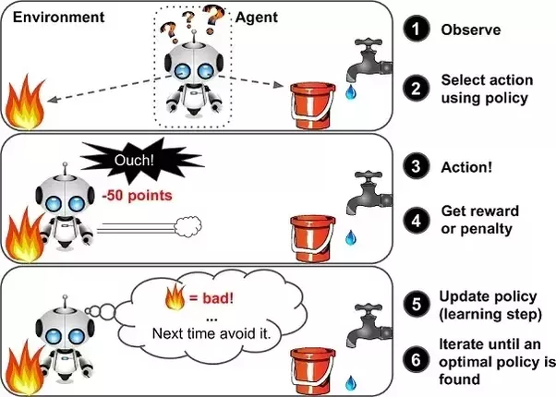

In the above example, we can see that the agent is given 2 options i.e. a path with water or a path with fire. A reinforcement algorithm works on reward a system i.e. if the agent uses the fire path then the rewards are subtracted and agent tries to learn that it should avoid the fire path. If it had chosen the water path or the safe path then some points would have been added to the reward points, the agent then would try to learn what path is safe and what path isn’t.

It is basically leveraging the rewards obtained, the agent improves its environment knowledge to select the next action.

**Applications of Supervised Learning**

Supervised Learning Algorithms are used in a variety of applications. Let’s go through some of the most well-known applications.

* **BioInformatics** – This is one of the most well-known applications of Supervised Learning because most of us use it in our day-to-day lives. BioInformatics is the storage of Biological Information of us humans such as fingerprints, iris texture, earlobe and so on. Cellphones of today are capable of learning our biological information and are then able to authenticate us bringing up the security of the system. Smartphones such as iPhones, Google Pixel are capable of facial recognition while OnePlus, Samsung is capable of In-display finger recognition.
* [**Speech Recognition**](https://www.edureka.co/blog/speech-recognition-python/) – This is the kind of application where you teach the algorithm about your voice and it will be able to recognize you. The most well-known real-world applications are virtual assistants such as Google Assistant and Siri, which will wake up to the keyword with your voice only.
* **Spam Detection** – This application is used where the unreal or computer-based messages and E-Mails are to be blocked. G-Mail has an algorithm that learns the different keywords which could be fake such as “You are the winner of something” and so forth and blocks those messages directly. OnePlus Messages App gives the user the task of making the application learn which keywords need to be blocked and the app will block those messages with the keyword.
* [**Object-Recognition**](https://www.edureka.co/blog/tensorflow-object-detection-tutorial/)**for Vision** – This kind of application is used when you need to identify something. You have a huge dataset which you use to teach your algorithm and this can be used to recognize a new instance. [Raspberry Pi](https://www.edureka.co/blog/raspberry-pi-tutorial/) algorithms which detect objects are the most well-known example.

Those were some of the places where Supervised Learning has shined and shown its grit in the real world of today. With that, let us move over to the differences between Supervised and Unsupervised learning.

## **Supervised vs. Unsupervised Learning**

|  |  |  |
| --- | --- | --- |
| **Parameter** | **Supervised Learning** | **Unsupervised Learning** |
| Dataset | Labelled | Unlabelled |
| Method of Learning | Guided learning | The algorithm learns by itself using dataset |
| Complexity | Simpler method | Computationally complex |
| Accuracy | More Accurate | Less Accurate |

## 

## Applications of unsupervised machine learning

Some applications of unsupervised machine learning techniques are:

* Clustering automatically split the dataset into groups base on their similarities
* Anomaly detection can discover unusual data points in your dataset. It is useful for finding fraudulent transactions
* Association mining identifies sets of items which often occur together in your dataset
* Latent variable models are widely used for data preprocessing. Like reducing the number of features in a dataset or decomposing the dataset into multiple components

### Machine learning is a form of artificial intelligence

Machine learning is a sub-category of [artificial intelligence](https://www.hpe.com/in/en/what-is/artificial-intelligence.html) and effectively automates the process of analytical model building and allows machines to adapt to new scenarios independently.

Whether or not you’re excited by the idea of artificial neural networks one day growing sophisticated enough to replicate human consciousness, there are undeniable practical advantages to machine learning, namely:

* **Intelligent big data management** – The sheer volume and variety of data being generated as humans and other environmental forces interact with technology would be impossible to process and draw insights from without the speed and sophistication of machine learning.
* **Smart devices** – From wearable devices that track health and fitness goals to self-driving cars to "smart cities" with infrastructure that can automatically reduce wasted time and energy, the [Internet of Things (IoT)](https://www.hpe.com/in/en/what-is/internet-of-things.html) holds great promise, and machine learning can help make sense of this significant increase in data.
* **Rich consumer experiences** – Machine learning enables search engines, web apps and other technology to customise results and recommendations to match user preferences, creating delightfully personalised experiences for consumers.

### How does machine learning work?

Machine learning is incredibly complex and how it works varies depending on the task and the algorithm used to accomplish it. However, at its core, a machine learning model is a computer looking at data and identifying patterns, and then using those insights to complete its assigned task more effectively. Any task that relies upon a set of data points or rules can be automated using machine learning, even those more complex tasks such as responding to customer service calls and reviewing CVs.

Depending on the situation, machine learning algorithms function using more or less human intervention/reinforcement. The four major machine learning models are supervised learning, unsupervised learning, semi-supervised learning and reinforcement learning.

With **supervised learning**, the computer is provided with a labelled set of data that enables it to learn how to do a human task. This is the least complex model, as it attempts to replicate human learning.

With **unsupervised learning**, the computer is provided with unlabelled data and extracts previously unknown patterns or insights from it. There are many different ways that machine learning algorithms do this, including:

* Clustering, in which the computer finds similar data points within a data set and groups them accordingly (creating “clusters”).
* Density estimation, in which the computer discovers insights by looking at how a data set is distributed.
* Anomaly detection, in which the computer identifies data points within a data set that are significantly different from the rest of the data.
* Principal component analysis (PCA), in which the computer analyses a data set and summarises it so that it can be used to make accurate predictions.

With **semi-supervised learning**, the computer is provided with a set of partially labelled data and performs its task using the labelled data to understand the parameters for interpreting the unlabelled data.

With **reinforcement learning**, the computer observes its environment and uses that data to identify the ideal behaviour that will minimise risk and/or maximise reward. This is an iterative approach that requires some kind of reinforcement signal to help the computer better identify its best action.

## RELATED RESOURCES

* [TAKING THE ENTERPRISE AI JOURNEY – GORILLA GUIDE](https://www.hpe.com/in/en/pdfViewer.html?docId=a50002397&parentPage=/in/en/what-is/machine-learning&resourceTitle=Taking-the-Enterprise-AI-Journey&jumpid=in_psnow_1c2349d7-5aa1-4e2e-8622-84c0dd021ddd_gaiw&hf=regular&rpv=1639644824925)

### How are deep learning and machine learning related?

Machine learning is the broader category of algorithms that are able to take a data set and use it to identify patterns, discover insights and/or make predictions. [Deep learning](https://www.hpe.com/in/en/compute/hpc/deep-learning.html) is a particular branch of machine learning that takes ML’s functionality and moves beyond its capabilities.

With machine learning in general, there is some human involvement in that engineers are able to review an algorithm’s results and make adjustments to it based on their accuracy. Deep learning doesn’t rely on this review. Instead, a deep learning algorithm uses its own **neural network** to check the accuracy of its results and then learn from them.

A deep learning algorithm’s neural network is a structure of algorithms that are layered to replicate the structure of the human brain. Accordingly, the neural network learns how to get better at a task over time without engineers providing it with feedback.

The two major stages of a neural network’s development are [**training and inference.**](https://www.hpe.com/in/en/resources/solutions/ai-industrialization.html) Training is the initial stage in which the deep learning algorithm is provided with a data set and tasked with interpreting what that data set represents. Engineers then provide the neural network with feedback about the accuracy of its interpretation, and it adjusts accordingly. There may be many iterations of this process. **Inference**is when the neural network is deployed and is able to take a data set it has never seen before and make accurate predictions about what it represents.

### How MLOps delivers the benefits of machine learning across enterprise applications

Machine learning is the catalyst for a strong, flexible and resilient enterprise. Smart organisations choose ML to generate top-to-bottom growth, employee productivity and customer satisfaction.

Many enterprises achieve success with a few ML use cases, but that’s really just the beginning of the journey. Experimenting with ML may come first, but what needs to follow is the integration of ML models into business applications and processes so it can be scaled across the enterprise.

Many organisations lack the skills, processes and tools to accomplish this level of enterprise-wide integration. In order to successfully achieve ML at scale, companies should consider investing in **MLOps**, which includes the process, tools and technology that streamline and standardise each stage of the ML lifecycle, from model development to operationalisation. The emerging field of MLOps aims to deliver agility and speed to the ML lifecycle. It can be compared to what DevOps has done for the software development lifecycle.

To progress from ML experimentation to ML operationalisation, enterprises need strong MLOps processes. MLOps not only gives an organisation a competitive edge but also makes it possible for the organisation to implement other machine learning use cases. This results in other benefits, including the creation of stronger talent through increased skills and a more collaborative environment, plus increased profitability, better customer experiences and increased revenue growth.1

**How enterprises are using machine learning**

Across vertical industries, ML technologies and techniques are being deployed successfully, providing organisations with tangible, real-world results.

In **financial services** for example, banks are using ML predictive models that look across a massive array of interrelated measures to better understand and meet customer needs. ML predictive models are also capable of uncovering and limiting exposure to risk. Banks can identify cyber threats, track and document fraudulent customer behaviour, and better predict risk for new products. Top use cases for ML in banking include fraud detection and mitigation, personal financial adviser services, and credit scoring and loan analysis.

In **manufacturing**, companies have embraced automation and are now instrumenting both equipment and processes. They use ML modelling to reorganise and optimise production in a way that is both responsive to current demand and conscious of future change. The end result is a manufacturing process that is both agile and resilient. The top three ML use cases identified in manufacturing include yield improvements, root cause analysis, and supply chain and inventory management.

**What is machine learning?**

Machine learning (ML) is a type of artificial intelligence ([AI](https://www.techtarget.com/searchenterpriseai/definition/AI-Artificial-Intelligence)) that allows software applications to become more accurate at predicting outcomes without being explicitly programmed to do so. Machine learning [algorithms](https://whatis.techtarget.com/definition/algorithm) use historical data as input to predict new output values.

[Recommendation engines](https://whatis.techtarget.com/definition/recommendation-engine) are a common use case for machine learning. Other popular uses include fraud detection, spam filtering, malware threat detection, [business process automation](https://searchcio.techtarget.com/definition/business-process-automation) (BPA) and [predictive maintenance](https://whatis.techtarget.com/definition/predictive-maintenance-PdM).

**Why is machine learning important?**

Machine learning is important because it gives enterprises a view of trends in customer behavior and business operational patterns, as well as supports the development of new products. Many of today's leading companies, such as Facebook, Google and Uber, make machine learning a central part of their operations. Machine learning has become a significant competitive differentiator for many companies.

**What are the different types of machine learning?**

Classical machine learning is often categorized by how an algorithm learns to become more accurate in its predictions. There are four basic approaches:[supervised](https://www.techtarget.com/searchenterpriseai/definition/supervised-learning) learning, [unsupervised](https://whatis.techtarget.com/definition/unsupervised-learning) learning, semi-supervised learning and reinforcement learning. The type of algorithm data scientists choose to use depends on what type of data they want to predict.

* **Supervised learning:** In this type of machine learning, [data scientists](https://www.techtarget.com/searchenterpriseai/definition/data-scientist) supply algorithms with labeled training data and define the variables they want the algorithm to assess for correlations. Both the input and the output of the algorithm is specified.
* **Unsupervised learning:** This type of machine learning involves algorithms that train on unlabeled data. The algorithm scans through data sets looking for any meaningful connection. The data that algorithms train on as well as the predictions or recommendations they output are predetermined.
* **Semi-supervised learning:** This approach to machine learning involves a mix of the two preceding types. Data scientists may feed an algorithm mostly labeled [training data](https://www.techtarget.com/searchenterpriseai/feature/Using-small-data-sets-for-machine-learning-models-sees-growth), but the model is free to explore the data on its own and develop its own understanding of the data set.
* **Reinforcement learning:**Data scientists typically use [reinforcement learning](https://www.techtarget.com/searchenterpriseai/definition/reinforcement-learning) to teach a machine to complete a multi-step process for which there are clearly defined rules. Data scientists program an algorithm to complete a task and give it positive or negative cues as it works out how to complete a task. But for the most part, the algorithm decides on its own what steps to take along the way.

**How does supervised machine learning work?**

Supervised machine learning requires the [data scientist](https://searchbusinessanalytics.techtarget.com/feature/Key-differences-of-a-data-scientist-vs-data-engineer) to train the algorithm with both labeled inputs and desired outputs. Supervised learning algorithms are good for the following tasks:

* **Binary classification:**Dividing data into two categories.
* **Multi-class classification:**Choosing between more than two types of answers.
* **Regression modeling:** Predicting continuous values.
* **Ensembling:** Combining the predictions of multiple machine learning models to produce an accurate prediction.

**How does unsupervised machine learning work?**

Unsupervised machine learning algorithms do not require data to be labeled. They sift through unlabeled data to look for patterns that can be used to group data points into subsets. Most types of deep learning, including [neural networks](https://www.techtarget.com/searchenterpriseai/definition/neural-network), are unsupervised algorithms. Unsupervised learning algorithms are good for the following tasks:

* **Clustering:** Splitting the dataset into groups based on similarity.
* **Anomaly detection:** Identifying unusual data points in a data set.
* **Association mining:** Identifying sets of items in a data set that frequently occur together.
* **Dimensionality reduction:**Reducing the number of variables in a data set.

**How does semi-supervised learning work?**

Semi-supervised learning works by data scientists feeding a small amount of [labeled training data](https://www.techtarget.com/searchenterpriseai/feature/Labeled-data-brings-machine-learning-applications-to-life) to an algorithm. From this, the algorithm learns the dimensions of the data set, which it can then apply to new, unlabeled data. The performance of algorithms typically improves when they train on labeled data sets. But labeling data can be time consuming and expensive. Semi-supervised learning strikes a middle ground between the performance of supervised learning and the efficiency of unsupervised learning. Some areas where semi-supervised learning is used include:

* **Machine translation:** Teaching algorithms to translate language based on less than a full dictionary of words.
* **Fraud detection:** Identifying cases of fraud when you only have a few positive examples.
* **Labelling data:** Algorithms trained on small data sets can learn to [apply data labels](https://whatis.techtarget.com/definition/data-labeling) to larger sets automatically.

**How does reinforcement learning work?**

Reinforcement learning works by [programming an algorithm](https://www.techtarget.com/searchenterpriseai/feature/5-types-of-machine-learning-algorithms-you-should-know) with a distinct goal and a prescribed set of rules for accomplishing that goal. Data scientists also program the algorithm to seek positive rewards -- which it receives when it performs an action that is beneficial toward the ultimate goal -- and avoid punishments -- which it receives when it performs an action that gets it farther away from its ultimate goal. Reinforcement learning is often used in areas such as:

* **Robotics:** Robots can learn to perform tasks the physical world using this technique.
* **Video gameplay:** Reinforcement learning has been used to teach bots to play a number of video games.
* **Resource management:** Given finite resources and a defined goal, reinforcement learning can help enterprises plan out how to allocate resources.

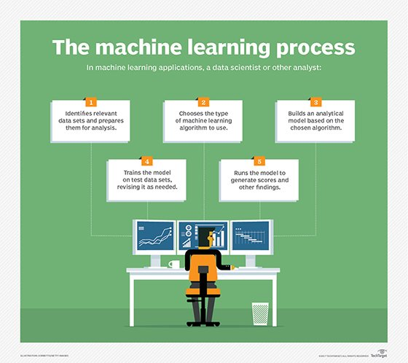

HOW MACHINE LEARNING WORKS

Machine learning is like statistics on steroids.

**Who's using machine learning and what's it used for?**

Today, machine learning is used in a wide range of applications. Perhaps one of the most well-known examples of machine learning in action is the [recommendation engine](https://whatis.techtarget.com/definition/recommendation-engine) that powers Facebook's news feed.

Facebook uses machine learning to personalize how each member's feed is delivered. If a member frequently stops to read a particular group's posts, the recommendation engine will start to show more of that group's activity earlier in the feed.

Behind the scenes, the engine is attempting to reinforce known patterns in the member's online behavior. Should the member change patterns and fail to read posts from that group in the coming weeks, the news feed will adjust accordingly.

In addition to recommendation engines, other uses for machine learning include the following:

* **Customer relationship management.** [CRM software](https://searchcustomerexperience.techtarget.com/definition/CRM-customer-relationship-management) can use machine learning models to analyze email and prompt sales team members to respond to the most important messages first. More advanced systems can even recommend potentially effective responses.
* **Business intelligence.** [BI and analytics](https://searchbusinessanalytics.techtarget.com/definition/business-intelligence-BI) vendors use machine learning in their software to identify potentially important data points, patterns of data points and anomalies.
* **Human resource information systems.** [HRIS systems](https://searchhrsoftware.techtarget.com/definition/HRIS) can use machine learning models to filter through applications and identify the best candidates for an open position.
* **Self-driving cars.** Machine learning algorithms can even make it possible for a [semi-autonomous car](https://www.techtarget.com/searchenterpriseai/definition/driverless-car) to recognize a partially visible object and alert the driver.
* **Virtual assistants.** [Smart assistants](https://searchcustomerexperience.techtarget.com/definition/virtual-assistant-AI-assistant) typically combine supervised and unsupervised machine learning models to interpret natural speech and supply context.

**What are the advantages and disadvantages of machine learning?**

Machine learning has seen use cases ranging from predicting customer behavior to forming the operating system for self-driving cars.

When it comes to advantages, machine learning can help enterprises understand their customers at a deeper level. By collecting customer data and correlating it with behaviors over time, machine learning algorithms can learn associations and help teams tailor product development and marketing initiatives to customer demand.

Some companies use machine learning as a primary driver in their business models. Uber, for example, uses algorithms to match drivers with riders. Google uses machine learning to surface the ride advertisements in searches.

But machine learning comes with disadvantages. First and foremost, it can be expensive. Machine learning projects are typically driven by data scientists, who command high salaries. These projects also require software infrastructure that can be expensive.

There is also the problem of machine learning bias. Algorithms trained on data sets that exclude certain populations or contain errors can lead to inaccurate models of the world that, at best, fail and, at worst, are discriminatory. When an enterprise bases core business processes on biased models it can run into regulatory and reputational harm.

**How to choose the right machine learning model**

The process of choosing the right machine learning model to solve a problem can be time consuming if not approached strategically.

**Step 1:** Align the problem with potential data inputs that should be considered for the solution. This step requires help from data scientists and experts who have a deep understanding of the problem.

**Step 2:** Collect data, format it and label the data if necessary. This step is typically led by data scientists, with help from [data wranglers](https://whatis.techtarget.com/definition/data-janitor-data-wrangler).

**Step 3:** Chose which algorithm(s) to use and test to see how well they perform. This step is usually carried out by data scientists.

**Step 4:** Continue to fine tune outputs until they reach an acceptable level of accuracy. This step is usually carried out by data scientists with feedback from experts who have a deep understanding of the problem.

**Importance of human interpretable machine learning**

Explaining how a specific ML model works can be challenging when the model is complex. There are some vertical industries where data scientists have to use simple machine learning models because it's important for the business to explain how every decision was made. This is especially true in industries with heavy [compliance burdens](https://searchcompliance.techtarget.com/definition/compliance-burden) such as banking and insurance.

Complex models can produce accurate predictions, but explaining to a lay person how an output was determined can be difficult.

**What is the future of machine learning?**

While machine learning algorithms have been around for decades, they've attained new popularity as [artificial intelligence](https://www.techtarget.com/searchenterpriseai/definition/AI-Artificial-Intelligence) has grown in prominence. Deep learning models, in particular, power today's most advanced AI applications.

Machine learning platforms are among enterprise technology's most competitive realms, with most major vendors, including Amazon, Google, Microsoft, IBM and others, racing to sign customers up for platform services that cover the spectrum of machine learning activities, including data collection, [data preparation](https://searchbusinessanalytics.techtarget.com/definition/data-preparation), data classification, model building, training and application deployment.

As machine learning continues to increase in importance to business operations and AI becomes more practical in enterprise settings, the machine learning platform wars will only intensify.

Continued research into deep learning and AI is increasingly focused on developing more general applications. Today's AI models require extensive training in order to produce an algorithm that is highly optimized to perform one task. But some researchers are exploring ways to make models more flexible and are seeking techniques that allow a machine to apply context learned from one task to future, different tasks.

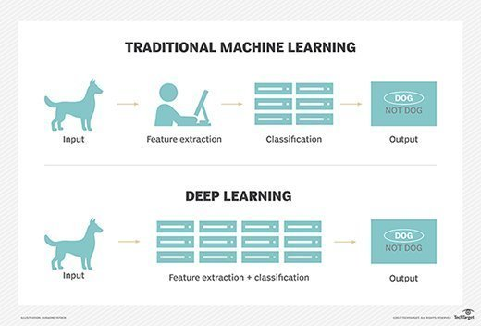

Deep learning works in very different ways than traditional machine learning.

**How has machine learning evolved?**

1642 - Blaise Pascal invents a mechanical machine that can add, subtract, multiply and divide.

1679 - Gottfried Wilhelm Leibniz devises the system of [binary](https://whatis.techtarget.com/definition/binary) code.

1834 - Charles Babbage conceives the idea for a general all-purpose device that could be programmed with punched cards.

1842 - [Ada Lovelace](https://whatis.techtarget.com/definition/Augusta-Ada-King-countess-of-Lovelace-Ada-Lovelace-Lady-Byron) describes a sequence of operations for solving mathematical problems using Charles Babbage's theoretical [punch-card machine](https://whatis.techtarget.com/reference/History-of-the-punch-card) and becomes the first programmer.

1847 - George Boole creates [Boolean](https://whatis.techtarget.com/definition/Boolean) logic, a form of algebra in which all values can be reduced to the binary values of true or false.

1936 - English logician and [cryptanalyst Alan Turing](https://www.techtarget.com/searchenterpriseai/definition/Turing-test) proposes a universal machine that could decipher and execute a set of instructions. His published proof is considered the basis of computer science.

1952 - Arthur Samuel creates a program to help an IBM computer get better at checkers the more it plays.

1959 - MADALINE becomes the first [artificial neural network](https://www.techtarget.com/searchenterpriseai/definition/neural-network) applied to a real-world problem: removing echoes from phone lines.

1985 - Terry Sejnowski's and Charles Rosenberg's artificial neural network taught itself how to correctly pronounce 20,000 words in one week.

1997 - IBM's Deep Blue beat chess grandmaster Garry Kasparov.

1999 - A [CAD](https://whatis.techtarget.com/definition/CAD-computer-aided-design) prototype intelligent workstation reviewed 22,000 mammograms and detected cancer 52% more accurately than radiologists did.

2006 - Computer scientist Geoffrey Hinton invents the term [deep learning](https://www.techtarget.com/searchenterpriseai/definition/deep-learning-deep-neural-network) to describe neural net research.

2012 - An unsupervised neural network created by Google learned to recognize cats in YouTube videos with 74.8% accuracy.

2014 - A [chatbot](https://searchcustomerexperience.techtarget.com/definition/chatbot) passes the Turing Test by convincing 33% of human judges that it was a Ukrainian teen named Eugene Goostman.

2014 - Google's AlphaGo defeats the human champion in Go, the most difficult board game in the world.

2016 - LipNet, DeepMind's artificial intelligence system, identifies lip-read words in video with an accuracy of 93.4%.

2019 - Amazon controls 70% of the market share for [virtual assistants](https://searchcustomerexperience.techtarget.com/definition/virtual-assistant-AI-assistant) in the U.S.

**What is Reinforcement Learning?**

**Reinforcement Learning** is defined as a Machine Learning method that is concerned with how software agents should take actions in an environment. Reinforcement Learning is a part of the deep learning method that helps you to maximize some portion of the cumulative reward.

This neural network learning method helps you to learn how to attain a complex objective or maximize a specific dimension over many steps.

**Important Components of Deep Reinforcement Learning Method**

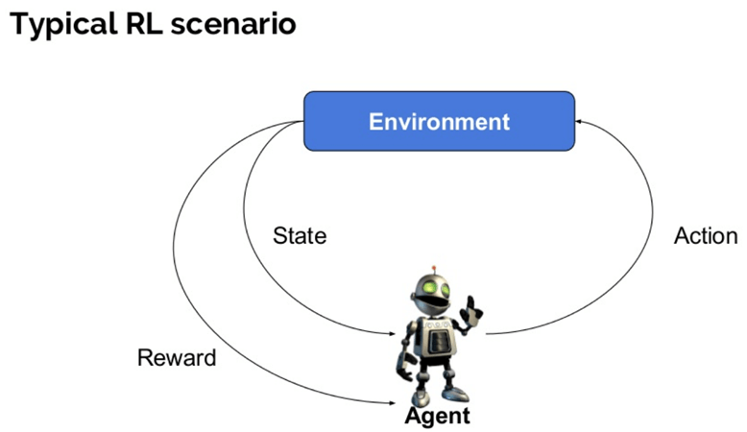

Here are some important terms used in Reinforcement AI:

* **Agent:**It is an assumed entity which performs actions in an environment to gain some reward.
* **Environment (e):**A scenario that an agent has to face.
* **Reward (R):**An immediate return given to an agent when he or she performs specific action or task.
* **State (s):**State refers to the current situation returned by the environment.
* **Policy (π):**It is a strategy which applies by the agent to decide the next action based on the current state.
* **Value (V):**It is expected long-term return with discount, as compared to the short-term reward.
* **Value Function:**Itspecifies the value of a state that is the total amount of reward. It is an agent which should be expected beginning from that state.
* **Model of the environment:**This mimics the behavior of the environment. It helps you to make inferences to be made and also determine how the environment will behave.
* **Model based methods:** It is a method for solving reinforcement learning problems which use model-based methods.
* **Q value or action value (Q):**Q value is quite similar to value. The only difference between the two is that it takes an additional parameter as a current action.

**How Reinforcement Learning works?**

Let’s see some simple example which helps you to illustrate the reinforcement learning mechanism.

Consider the scenario of teaching new tricks to your cat

How to write a TEST CASE Software Testing Tutorial

* As cat doesn’t understand English or any other human language, we can’t tell her directly what to do. Instead, we follow a different strategy.
* We emulate a situation, and the cat tries to respond in many different ways. If the cat’s response is the desired way, we will give her fish.
* Now whenever the cat is exposed to the same situation, the cat executes a similar action with even more enthusiastically in expectation of getting more reward(food).
* That’s like learning that cat gets from “what to do” from positive experiences.
* At the same time, the cat also learns what not do when faced with negative experiences.

**Example of Reinforcement Learning**

How Reinforcement Learning works

In this case,

* Your cat is an agent that is exposed to the environment. In this case, it is your house. An example of a state could be your cat sitting, and you use a specific word in for cat to walk.
* Our agent reacts by performing an action transition from one “state” to another “state.”
* For example, your cat goes from sitting to walking.
* The reaction of an agent is an action, and the policy is a method of selecting an action given a state in expectation of better outcomes.
* After the transition, they may get a reward or penalty in return.

**Reinforcement Learning Algorithms**

There are three approaches to implement a Reinforcement Learning algorithm.

**Value-Based:**

In a value-based Reinforcement Learning method, you should try to maximize a value function **V(s)**. In this method, the agent is expecting a long-term return of the current states under policy **π**.

**Policy-based:**

In a policy-based RL method, you try to come up with such a policy that the action performed in every state helps you to gain maximum reward in the future.

Two types of policy-based methods are:

* Deterministic: For any state, the same action is produced by the policy π.
* Stochastic: Every action has a certain probability, which is determined by the following equation.Stochastic Policy :

n{a\s) = P\A, = a\S, =S]

**Model-Based:**

In this Reinforcement Learning method, you need to create a virtual model for each environment. The agent learns to perform in that specific environment.

**Characteristics of Reinforcement Learning**

Here are important characteristics of reinforcement learning

* There is no supervisor, only a real number or reward signal
* Sequential decision making
* Time plays a crucial role in Reinforcement problems
* Feedback is always delayed, not instantaneous
* Agent’s actions determine the subsequent data it receives

**Types of Reinforcement Learning**

Two types of reinforcement learning methods are:

**Positive:**

It is defined as an event, that occurs because of specific behavior. It increases the strength and the frequency of the behavior and impacts positively on the action taken by the agent.

This type of Reinforcement helps you to maximize performance and sustain change for a more extended period. However, too much Reinforcement may lead to over-optimization of state, which can affect the results.

**Negative:**

Negative Reinforcement is defined as strengthening of behavior that occurs because of a negative condition which should have stopped or avoided. It helps you to define the minimum stand of performance. However, the drawback of this method is that it provides enough to meet up the minimum behavior.

**Learning Models of Reinforcement**

There are two important learning models in reinforcement learning:

* Markov Decision Process
* Q learning

**Markov Decision Process**

The following parameters are used to get a solution:

* Set of actions- A
* Set of states -S
* Reward- R
* Policy- n
* Value- V

The mathematical approach for mapping a solution in reinforcement Learning is recon as a Markov Decision Process or (MDP).

**Q-Learning**

Q learning is a value-based method of supplying information to inform which action an agent should take.

Let’s understand this method by the following example:

* There are five rooms in a building which are connected by doors.
* Each room is numbered 0 to 4
* The outside of the building can be one big outside area (5)
* Doors number 1 and 4 lead into the building from room 5

Next, you need to associate a reward value to each door:

* Doors which lead directly to the goal have a reward of 100
* Doors which is not directly connected to the target room gives zero reward
* As doors are two-way, and two arrows are assigned for each room
* Every arrow in the above image contains an instant reward value

**Explanation:**

In this image, you can view that room represents a state

Agent’s movement from one room to another represents an action

In the below-given image, a state is described as a node, while the arrows show the action.

For example, an agent traverse from room number 2 to 5

* Initial state = state 2
* State 2-> state 3
* State 3 -> state (2,1,4)
* State 4-> state (0,5,3)
* State 1-> state (5,3)
* State 0-> state 4

**Reinforcement Learning vs. Supervised Learning**

| **Parameters** | **Reinforcement Learning** | **Supervised Learning** |
| --- | --- | --- |
| Decision style | reinforcement learning helps you to take your decisions sequentially. | In this method, a decision is made on the input given at the beginning. |
| Works on | Works on interacting with the environment. | Works on examples or given sample data. |
| Dependency on decision | In RL method learning decision is dependent. Therefore, you should give labels to all the dependent decisions. | Supervised learning the decisions which are independent of each other, so labels are given for every decision. |
| Best suited | Supports and work better in AI, where human interaction is prevalent. | It is mostly operated with an interactive software system or applications. |
| Example | Chess game | Object recognition |

**Applications of Reinforcement Learning**

Here are applications of Reinforcement Learning:

* Robotics for industrial automation.
* Business strategy planning
* [Machine learning](https://www.guru99.com/machine-learning-tutorial.html) and data processing
* It helps you to create training systems that provide custom instruction and materials according to the requirement of students.
* Aircraft control and robot motion control

**Why use Reinforcement Learning?**

Here are prime reasons for using Reinforcement Learning:

* It helps you to find which situation needs an action
* Helps you to discover which action yields the highest reward over the longer period.
* Reinforcement Learning also provides the learning agent with a reward function.
* It also allows it to figure out the best method for obtaining large rewards.

**When Not to Use Reinforcement Learning?**

You can’t apply reinforcement learning model is all the situation. Here are some conditions when you should not use reinforcement learning model.

* When you have enough data to solve the problem with a supervised learning method
* You need to remember that Reinforcement Learning is computing-heavy and time-consuming. in particular when the action space is large.

**Challenges of Reinforcement Learning**

Here are the major challenges you will face while doing Reinforcement earning:

* Feature/reward design which should be very involved
* Parameters may affect the speed of learning.
* Realistic environments can have partial observability.
* Too much Reinforcement may lead to an overload of states which can diminish the results.
* Realistic environments can be non-stationary.